双流某重点小学二年级上学期英语期末试题
Part1 Listening(第一部分 听力)
一、Listen and number (听录音，给字母或单词编号)
( ) 1. A. G B. C C. E D. F
( ) 2. A. J B. L C. I D. A
( ) 3. A. kbd B. h C. xk D. st
( ) 4. A. ygp B. jgq C. mwv D. zed
( ) 5. A. please B. sing C. sweep D. swim
二、Listen and, circle (听录音，圈出听到的字母组合或单词)
( ) 1. A. car B. cat
( ) 2. A. building B. bin
( ) 3. A. some B. come
( ) 4. A. wait B. write
( ) 5. A. girl B. go
( ) 6. A. have B. hand
( ) 7. A. get on B. get off
( ) 8. A. sing with me B. swim with me
( ) 9. A. have a cake B. have some cake
( ) 10. A. live in Beijing B. love Beijing
三、Listen and tick (听录音，选出内容相符的图片)
( ) 1. Have some ________.
A.  B. 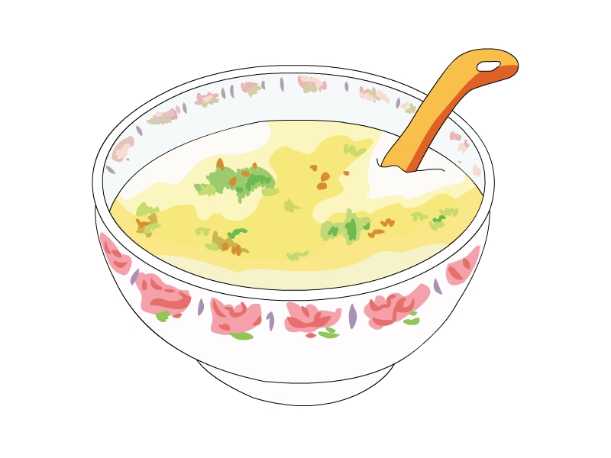
( ) 2. I like to ________.
A. 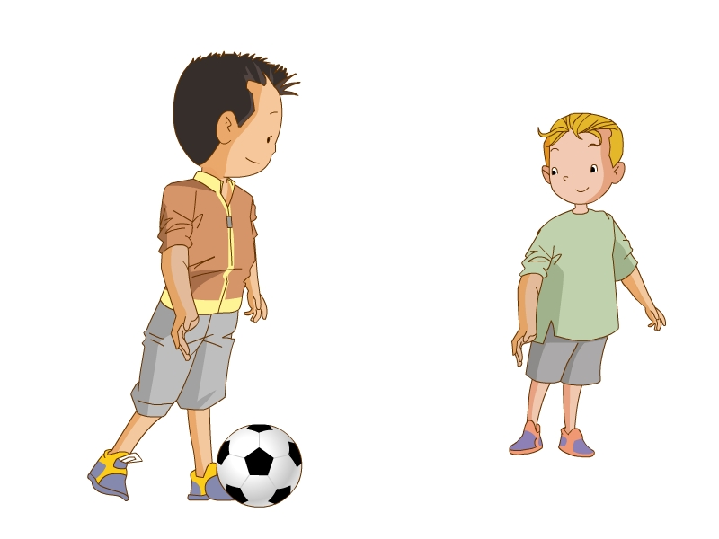 B. 
( ) 3. Tom goes to the park by ________.
A. 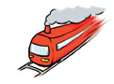 B. 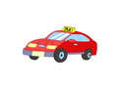
( ) 4. May I have some ________?
A.  B. 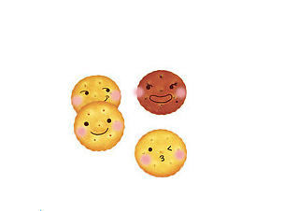
( ) 5. I use the ________.
A. 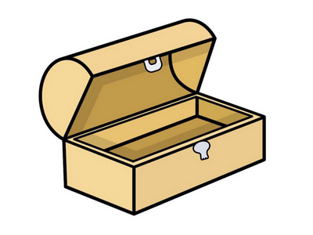 B. 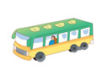
四、Listen and tick (听录音，在相应的格子里打“√”)
 | Shanghai | run | pizza | dance | bus
Sam
May
Kitty
Peter
Alice
Part2 Reading and writing(第二部分 读写)
一、Write the right letters (找邻居)
1. __ G __ 2. __ c __ 3. A __ __ 4. __ __ g 5. __ __ D
二、Look and write (根据图片，填入所缺的字母)
1. 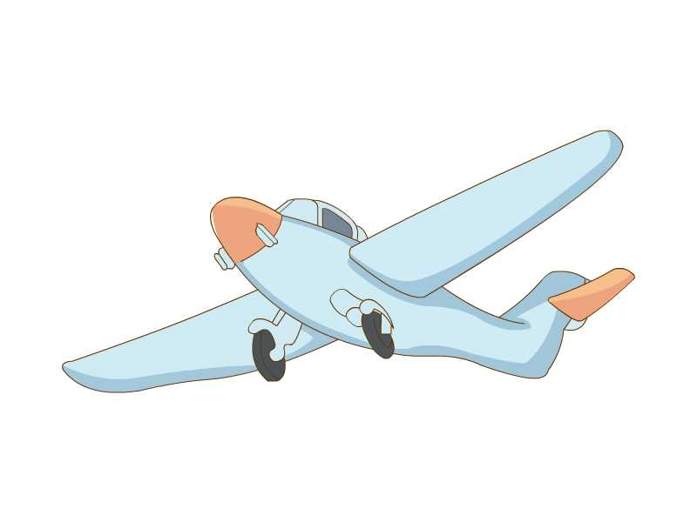 pl __ n __
2. 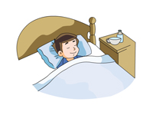 sl __ __ p
3.  __ ppl __
4. 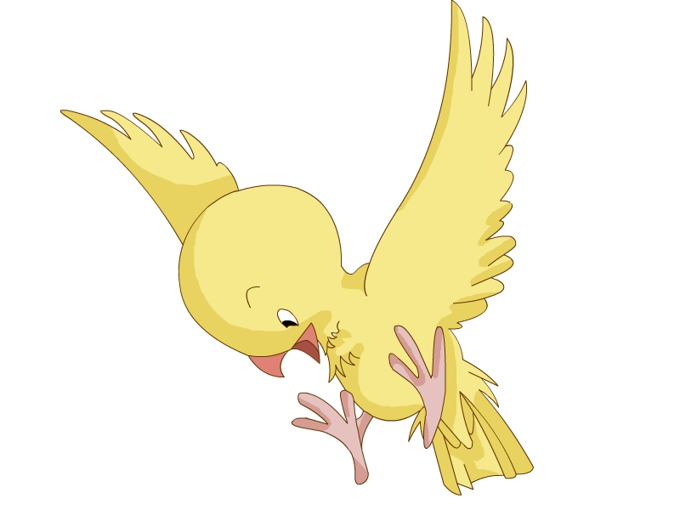 __ ir __
5. 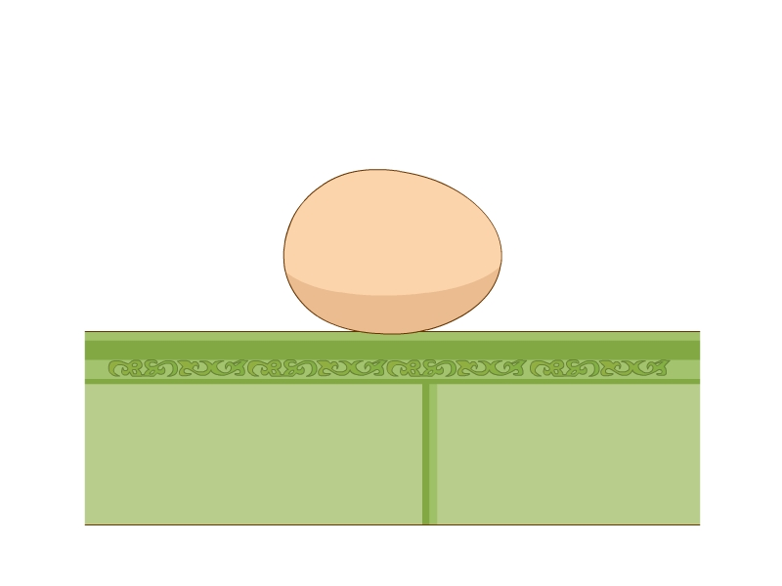 __ g __
三、Look and choose (根据图片，选择正确的句子)
( ) 1. A. Get in the bus. 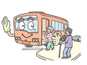
B. Get off the bus.
( ) 2. I’m hungry. 
A. May I have two hot dogs?
B. May I have three hot dogs?
( ) 3. What do you like to do?
A. I like to sing.
B. I like to swim.
( ) 4. How do you go to Hangzhou? 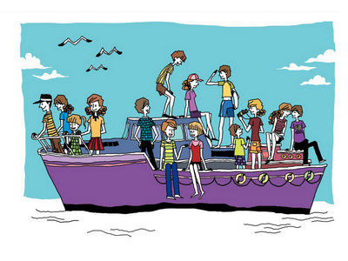
A. I go to Hangzhou by train.
B. I go to Hangzhou by ferry.
( ) 5. Down by the road waiting for van.
A. Beep, beep, beep.
B. Boop, boop, boop.
四、Look and choose (选出正确的单词或结构)
( ) 1. Clean the desk, please.
A. OK. B. Thank you.
( ) 2. Where do you live?
A. I live in Pudong. B. I love Pudong.
( ) 3. May I have ________ apple?
A. a B. an
( ) 4. Have ________ sweets.
A. a B. some
( ) 5. Spotty ________ a pizza.
A. have B. has
( ) 6. Come and play ________ me.
A.with B. to
( ) 7. I like ________ eat.
A. by B. to
( ) 8. Get ________ the bus.
A. on B. in
( ) 9. How ________ you go to the Great Wall?
A. by B. do
( ) 10. I go to Guangzhou ________ car.
A. by B.do
五、Match the sentences and the pictures (将句子与图片连线)
(1) I live in Shanghai A.
(2) May I have some milk? B. 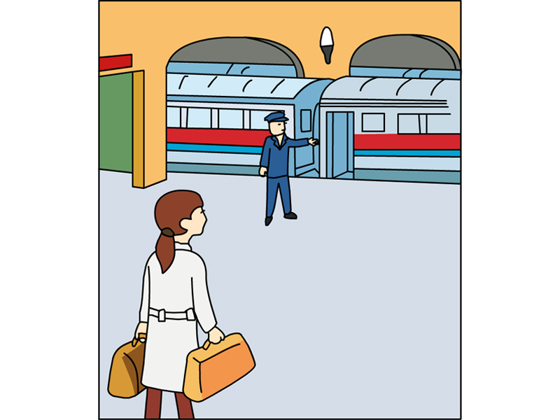
(3) I like to dance. C. 
(4) Have some soup. D. 
(5) Down by the station waiting for the train. E. 
参考答案
听力部分
听力材料
一、
1. E G F C
2. I J A L
3. dh kb xk st
4. zed mwv ygp jgq
5. sweep please swim sing
二、
1. car 2. building 3. come 4. write 5. girl 6. have 7. get on 8. swim with me 9. have some cake 10. love Beijing
三、
1. Have some noodles.
2. I like to play with the ball.
3. Tom goes to the park by taxi.
4. May I have some biscuits?
5. I use the bin.
四、
1. Sam likes to run.
2. May lives in Shanghai.
3. Kitty has a pizza.
4. Peter goes to school by bus.
5. Alice likes to dance.
听力答案
一、
1. BDAC
2. BDAC
3. BACD
4. CDBA
5. BDAC
二、
1-10 AABBAAABBB
三、
1-5 AABBA
四、
 | Shanghai | run | pizza | dance | bus
Sam |  | √
May | √
Kitty |  |  | √
Peter |  |  |  |  | √
Alice |  |  |  | √
笔试部分
一、
1. F; H 2.b; d 3. B C 4.e f 5. B C
二、
1. a; e 2. e; e 3. a; e 4. b; d 5. e; g
三、
1-5 ABBBA
四、
1-10 AABBBABABA
五、
(1)-(5) ECDAB

