双流某重点小学二年级上学期英语期末试题
一、慧眼识珠。
( ) l. father
A.  B.  C. 
( ) 2. ruler
A. 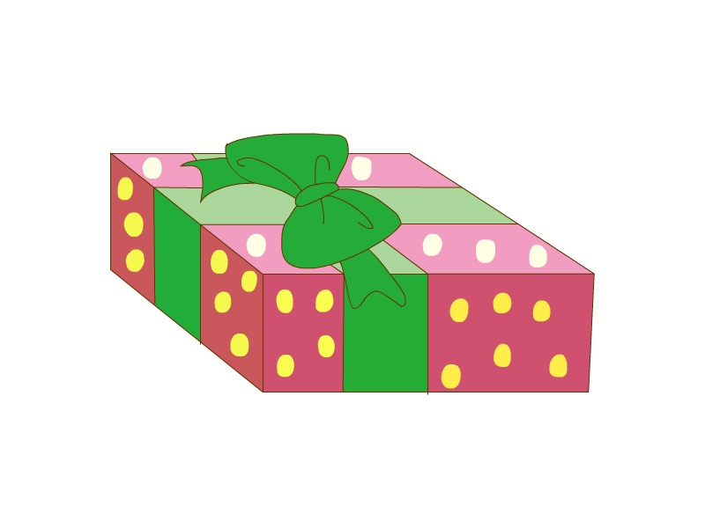 B. 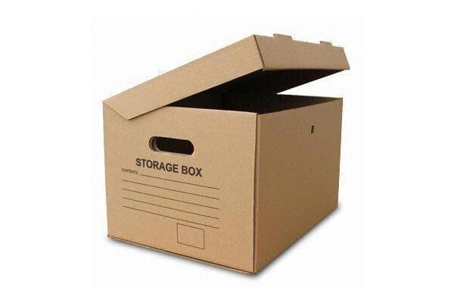 C. 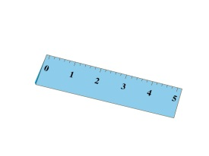
( ) 3. lake
A. 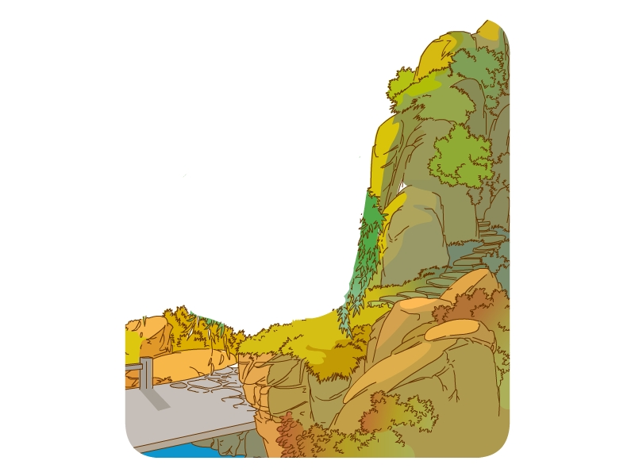 B. 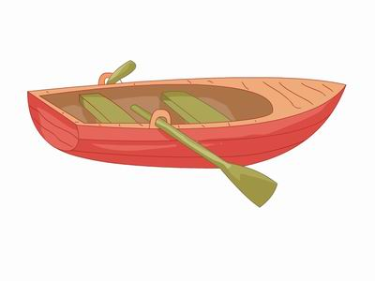 C. 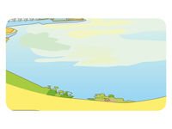
( ) 4. New Year
A. 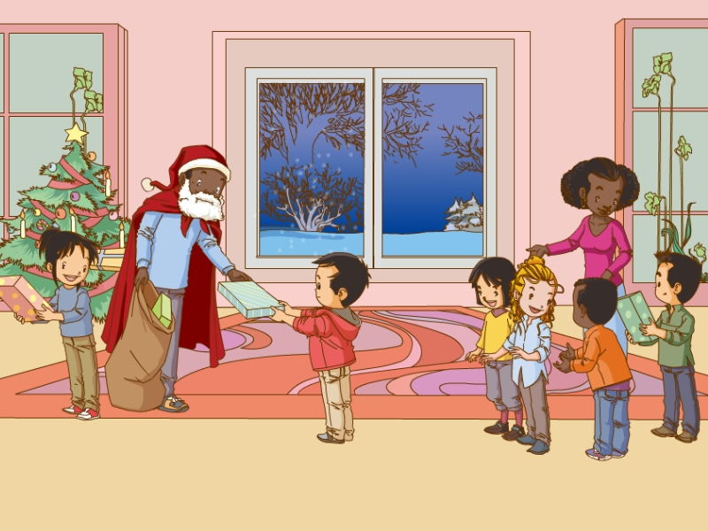 B. 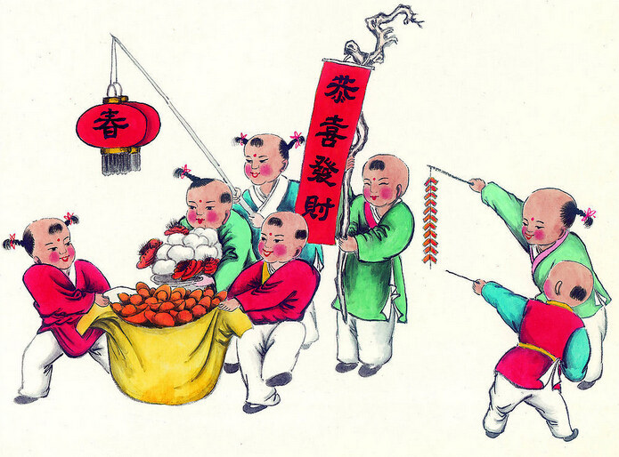 C. 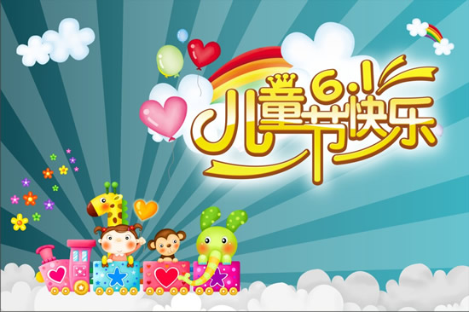
( ) 5. bird
A. 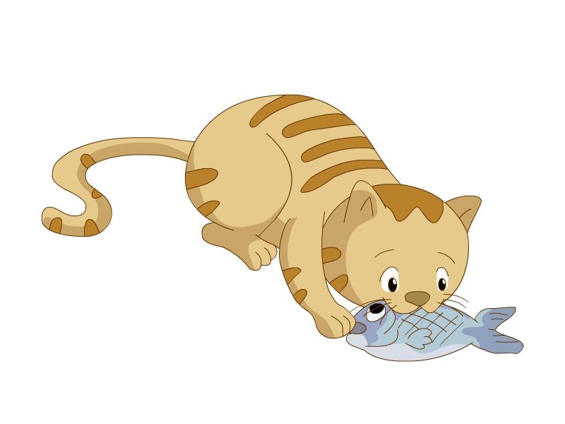 B. 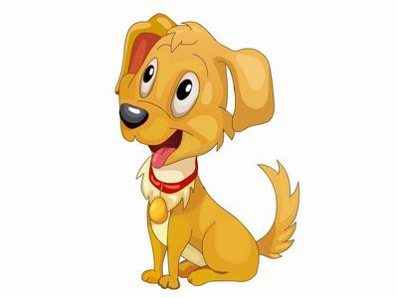 C. 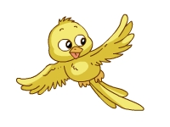
( ) 6. car
A. 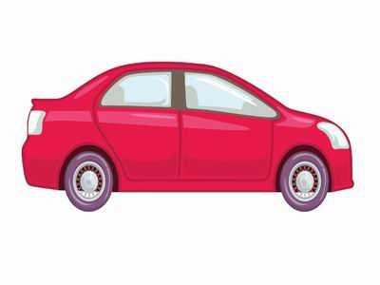 B. 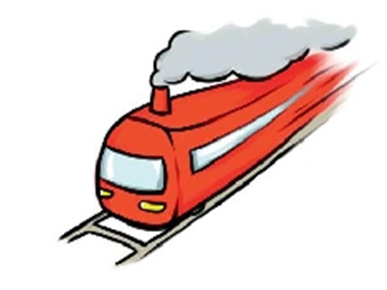 C. 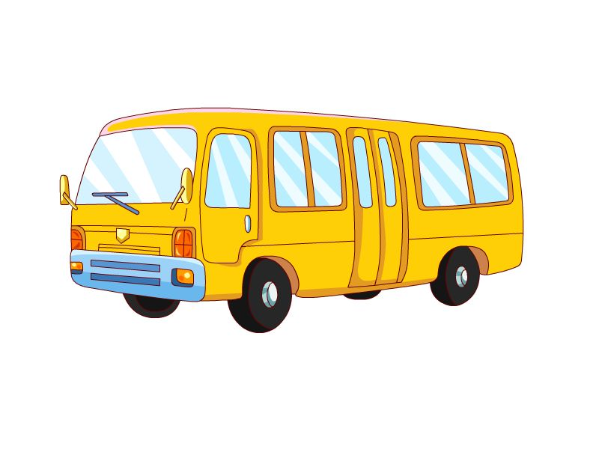
二、小小翻译家。
1. classmate ________ 2. 高兴的 ________
3. girl ________ 4. 新的 ________
5. Christmas ________ 6. 谢谢你 ________
7. pencil ________ 8. 英俊的 ________
9. the supermarket ________ 10. 在动物园 ________
三、各就各位。（给下列单词分类，写序号）
(1) Christmas (2) supermarket (3) cat (4) hill (5) ruler
(6) father (7) school (8) pencil (9) New Year (10) tree
(11) dog (12) sister (13) hospital (14) car (15) brother (16) schoolbag (17) monkey (18) lake (19) grass (20) flower
节日: ________________________________________________________________
家庭成员: ____________________________________________________________
交通工具: ____________________________________________________________
景物类: ______________________________________________________________文具类: ______________________________________________________________
动物类: ______________________________________________________________
公共设施: ____________________________________________________________
四、问句答语连线。
(1) Who is he? A. Yes, I do.
(2) What does he look like? B. He is my father.
(3) Where is my book? C. I’m going to the Beihai Park.
(4) Where are you going? D. He is tall.
(5) Do you like the plane? E. It is in your schoolbag.
五、读句子，判正“√”误“×”。
( ) 1. She is me brother.
( ) 2. He is a woman.
( ) 3. I am a boy.
( ) 4. What he like?
( ) 5. I’m going bookshop.
( ) 6.I like an apple.
六、读短文，圈出正确的单词。
Ann: Hello, Kate! Where are you going?
Kate: I am going to the park.
Ann: Me too. Let’s go. (我们一起去吧!)
Kate: What a beautiful park! Look, the lake is in the park.
Ann: Oh, there is a boat on the lake.
Kate: There are some boys in the boat.
Ann: Who is he?
Kate: He is my brother.
Ann: What’s his name?
Kate: His name is Bill. Is he is tall?
Ann: Yes, very (非常)tall.
(1) Kate and Ann are going to (the park/the zoo).
(2) There is a (tree/lake) in the park.
(3) Kate can see (看见) some (boys/birds) in the boat.
(4) Bill is Kate’s (brother/father).
(5) Bill is (short/tall).

参考答案
一、
1-6 ACCBCA
二、
1. 同班同学 2. happy 3. 女孩 4. new 5. 圣诞节 6. thank you 7. 铅笔 8. handsome 9. 超市10. at the zoo
三、
节日:(1) (9)
家庭成员: (6) (12) (15)
交通工具: (14)
景物类: (4) (10) (18) (19) (20)
文具类: (5) (8) (16)
动物类: (3) (11) (17)
公共设施: (2) (7) (13)
四、
(1)-(5) BDECA
五、
1-6 ××√××√
六、
(1)-(5) the park; lake; boys; brother; tall

