双流某重点小学二年级下学期英语期末试题
听力部分(50%)

- 听单词或短语，选择正确的选项填在括号里。（20%）
( )1. A. small B. big （ ）2. A. beef B. bread
( )3. A. fifty B. forty （ ）4. A. math book B.story-book
( )5. A. board B. door （ ）6. A.floor B. fan
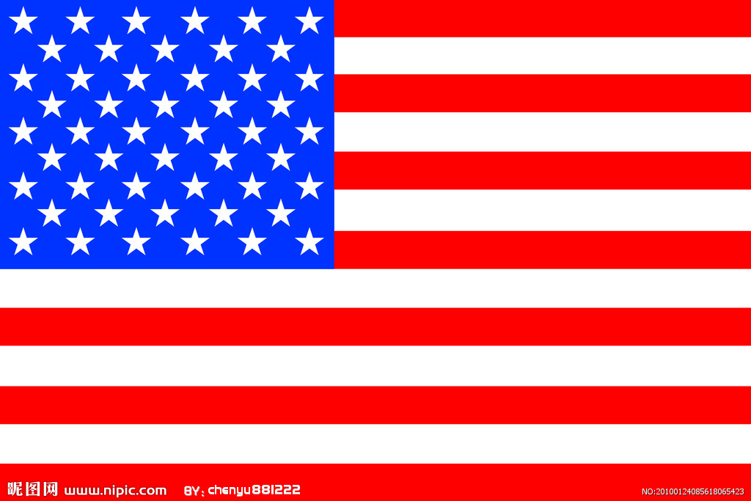
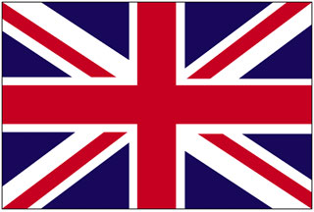
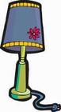
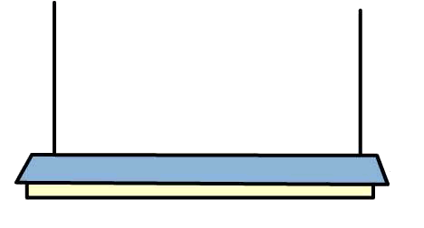
( )7. A. B. （ ）8. A. B.

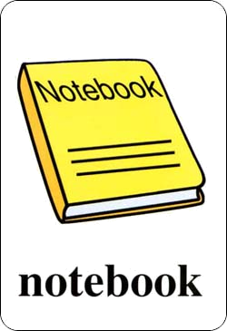

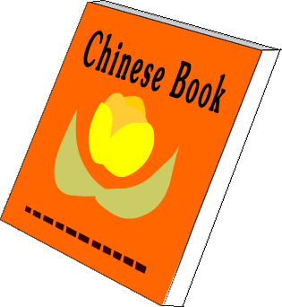
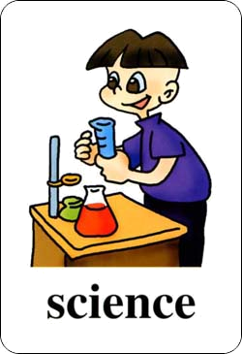
( )9. A. B. （ ）10. A. B.
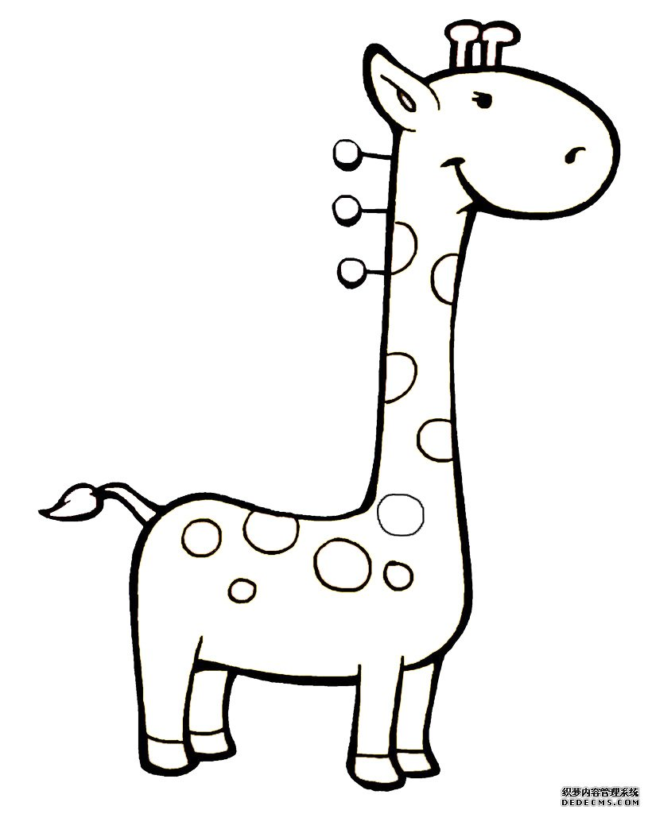

- 仔细听句子或对话，判断下列图片是否和听到的内容相符，相符的画 ，不相符的画 。 （10%）
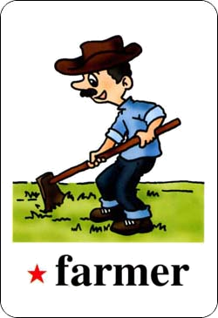
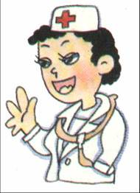
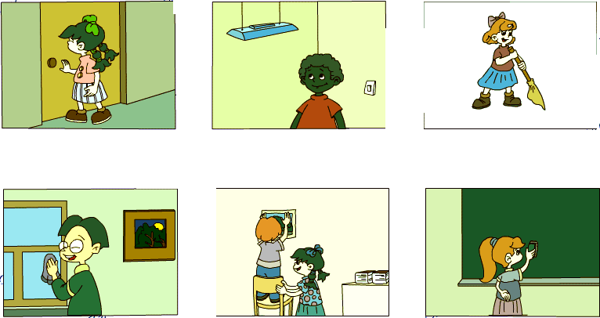
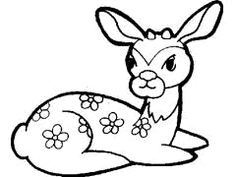
1. 2. 3. 4. 5.

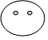

- 仔细听句子或对话，按顺序标号。（10%）

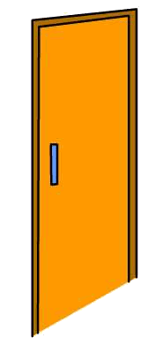
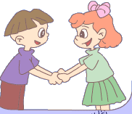

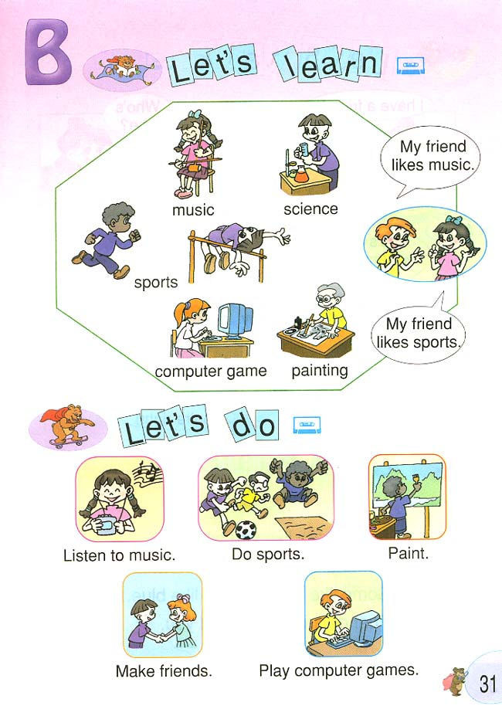
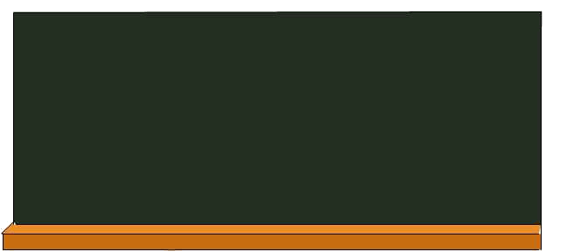

四、听音，选择你听到的句子，将序号填入题前括号内。10%
（ ）1、A. I have 20 story-books,32 pencils and 12 notebooks.
B. I have 12 math books,32pencils and 20 English books.

（ ）2、 A. He is tall and strong.
B. He has big eyes and big ears.

（ ）3、A. I like music.
B. He likes music.

（ ）4、A. We have a new classroom.
B. We have a new schoolbag.

（ ）5、A. I have 14 Chinese books.
B. I have 40 Chinese books.

笔试部分 50%
- 认读并圈出不同类的单词10%
1. twenty forty fifty bag
2. quiet computer thin strong
3. door painting wall floor
4. bear deer girrafe board
5. fan rice noodles beef

- 语言知识运用.连线（10%）
1. May I have a look? It’s green.
2. What colour is it? Sure.Here you are.
3. What’s his name? Many desks and chairs.
4. What’s in the classroom? It’s near the door.
5. Where is my seat? His name is ZhangPeng.
七、知识运用 .读句子，与图片情境相符的打“√”，不符的打“×”。（10%）
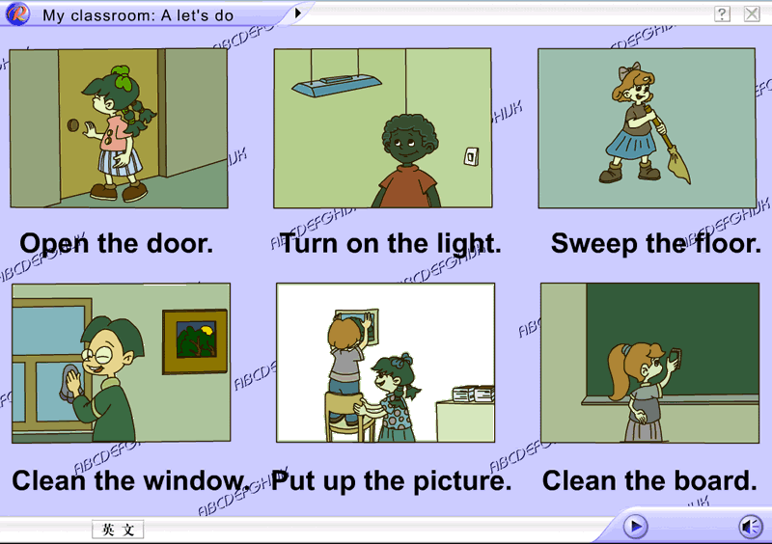
( ) 1. Put up the picture.

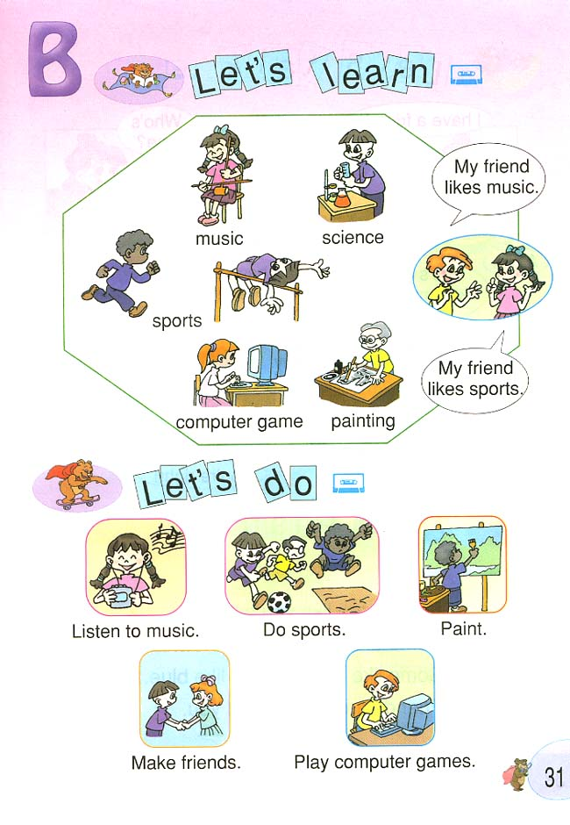
( ) 2. He likes sports.

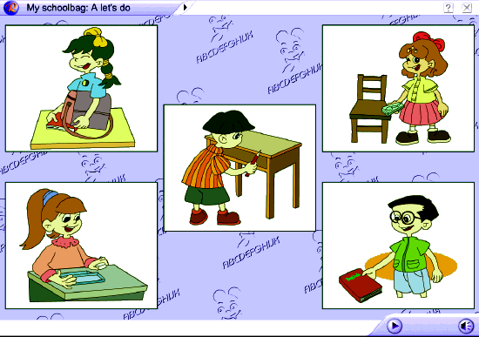
( ) 3. Put your English book on your head.

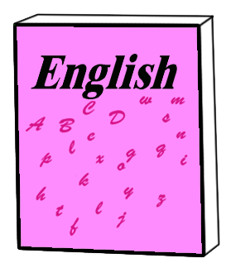
( )4. How many English books do you have?

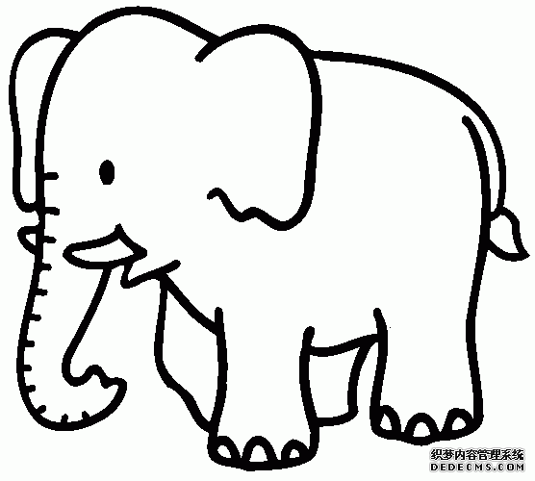
( )5. It has a long nose and big ears.

八、阅读并完成句子。（10分）ww w.xk b1.co m
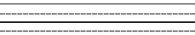
Hello!I’m Jack. I have two good s . John and Amy.John
朋友

is a . He is a . Amy is a .
男孩朋友
学生
女孩

She is a . .
老师

九、默写26个字母。（10分）

